**ANALYSIS REPORT**

**FOR**

**ACLED DATA ANALYSIS SYSTEM**

**BY GROUP 58**

Table of Contents

1 Introduction 3

2 Analysis of fatality versus year 3

2.1 Analysis 3

2.2 Observations and recommendation in this analysis 4

2.3 Recommendation 4

3 Analysis for interactions in different regions 4

3.1 Analysis 5

3.2 Observations and Recommendations 5

4 Analysis for fatalities from 1997 to 2014 5

4.1 Analysis 5

4.2 Observation and recommendation 6

5 Analysis for event type vs interactions 6

5.1 Analysis 7

5.2 Observation and Recommendations 7

6 Analysis for event type vs fatality 7

6.1 Analysis 8

6.2 Observation and recommendation 8

7 Analysis for event type per year against region 8

7.1 Analysis 8

7.2 Observation and recommendation 8

8 Analysis for interactions per year vs event type 9

8.1 Analysis for fatalities in a region 9

8.1.1 ACHOLI REGION 9

8.1.2 ELGON REGION 9

8.1.3 CENTRAL 1 REGION 10

8.1.4 CENTRAL 2 REGION 10

8.1.5 EAST CENTRAL REGION 11

8.1.6 KARAMOJONG REGION 12

8.1.7 SOUTH-WESTERN REGION 12

# Introduction

This analysis report comprises of all analysis on the ACLED data

# Analysis of fatality versus year

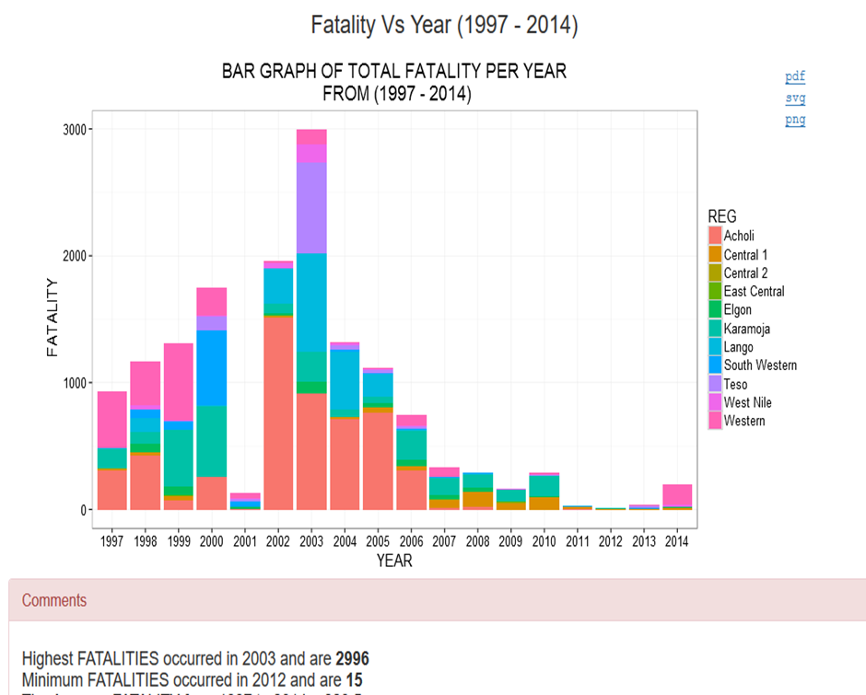

Figure 1: Analysis graph of Fatality versus Year

## Analysis

The highest number of fatalities occurred in 2003 mostly in Acholi region. The event types that caused the highest number of fatalities where mainly violence against civilians and battle no change according to ACLED according to the resource by Agence France Presse who were the dominant reporters. The actors involved where mainly either civilians or Uganda Military Forces against LRA rebels. This violence mainly resulted from attacks made by rebel raids in villages and military forces pursing rebels after attack on villages.

From 2004 to 2013, the fatality rate went on reducing but with the event type mainly remaining violence against civilians the most influential actors in these violence’s “the LRA rebels with time went on reducing” with other event types such as strikes rising up but carrying less fatalities. In years of 2005 to 2007 highest rate of fatalities where rotating around civilians and the Karamojong ethnic militia with fatalities resulting from cattle raids and disbarment of Guns but most of these where eliminated with time further predicting that fatalities will continue reducing with time.

## Observations and recommendation in this analysis

Fatality rates where high were any two forces interacted. For example in 1997, highest fatality occurred when ADF-NALU and police forces interacted.

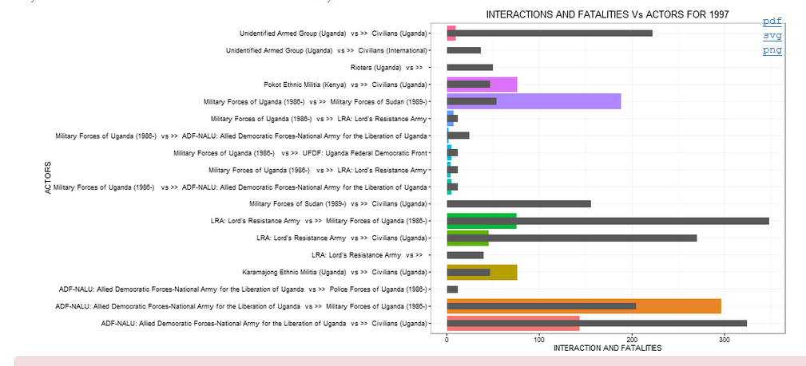

## Recommendation

We would suggest that in order to resolve issues that result into violence. We should use peaceful means.

# Analysis for interactions in different regions

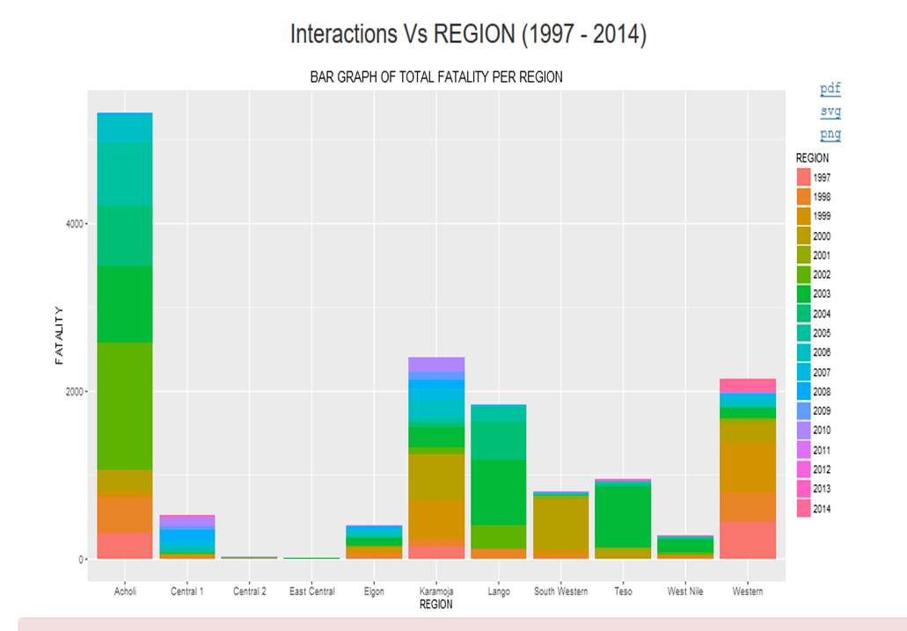

Figure 2: Analysis graph of Interactions versus Region for 1997 to 2014

## Analysis

Acholi region had the highest number of interactions according to the observation in the graph in the year 2003. The main event types where violence against civilians and battle no change according to ACLED data with mostly military forces and civilians against LRA rebels. East central regions had the least interactions in all the years mostly happening in 2003. Interactions have been reducing with time apart from the year 2014 when event types such as riots/protests caused an increase.

## Observations and Recommendations

In any event-type that involved civilians in the given regions there were high interactions. According to the attacks that happened it is clear that some regions still luck enough security due to some event types still happening in some regions since. We would highly suggest that concerned organizations take strict that will stop that violence that is still happening since and to use security measures accordingly.

# Analysis for fatalities from 1997 to 2014

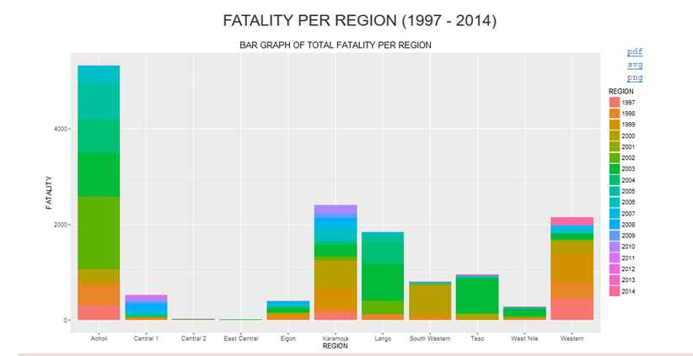

Figure 3: analysis graph of fatality versus Region.

## Analysis

Acholi had the highest fatalities among all regions with east central region having the lowest number of fatalities. The main event types that caused these fatalities were violence against civilians, battle no change in mainly 2003 and 2006. However, from 2003 especially in Acholi region fatalities have been reducing due to counter measures performed by one of the actors i.e. military forces. The military forces carried out disarmament of guns from the other actors that were the main cause of the violence. The violence involved raids on villages, making attacks against civilians. In Acholi, by 2009 such violence had reduced to almost zero. According to the graph, of recent in 2014, riots/protests emerged and lead to some fatalities. In general, fatalities have reduced in different regions with time.

## Observation and recommendation

Whereas fatalities have reduced generally, some regions are still having traces of fatality such as the western region and Karamojong region. This calls for diversion of security forces to tighten up security in those regions that still face such fatalities due to violence.

# Analysis for event type vs interactions

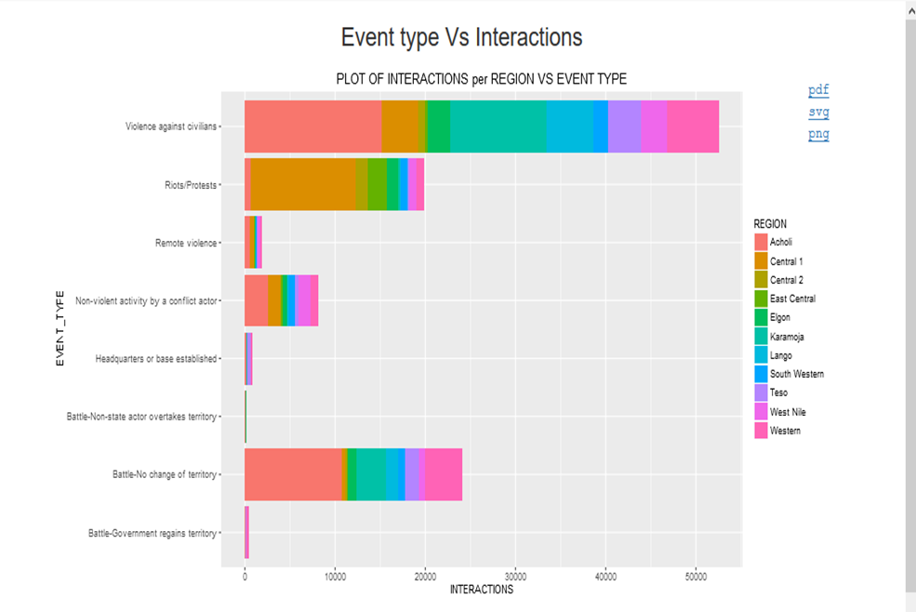

Figure 4: analysis graph of event-type versus interaction over the regions.

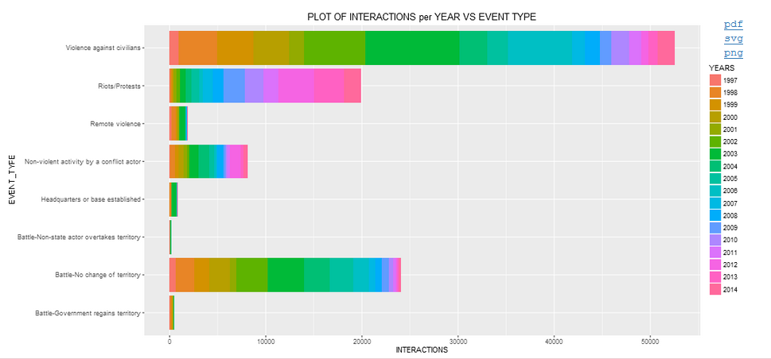

Figure 5: analysis of event-type versus interactions over the years

## Analysis

According to ACLED data, the event-type that had the highest interactions was violence against civilians especially in Acholi, lango and Karamojong regions. Followed by riots/ protests in the central region then battle no change in the region of WestNille. Battle non-state actor civilian as territory was the most non-occurring event type not appearing in some regions over the years. This judgement is based on the number of interactions.

## Observation and Recommendations

Some event types occur in almost all regions according to the interactions that happened. This calls for rapid response for security in search regions especially where such interactions are still happening.

# Analysis for event type vs fatality

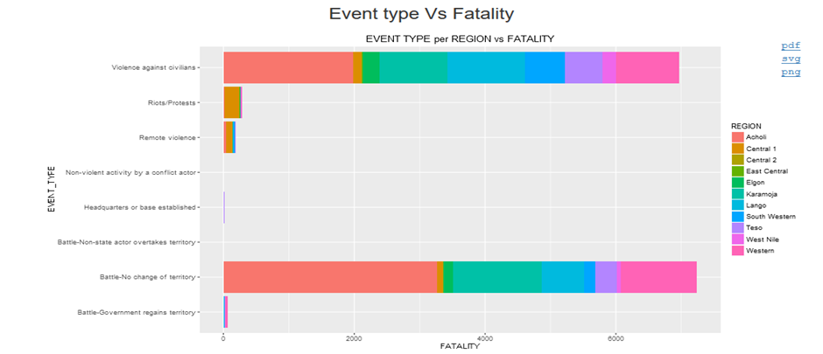

Figure 6: Analysis graph of event-type versus fatality over region

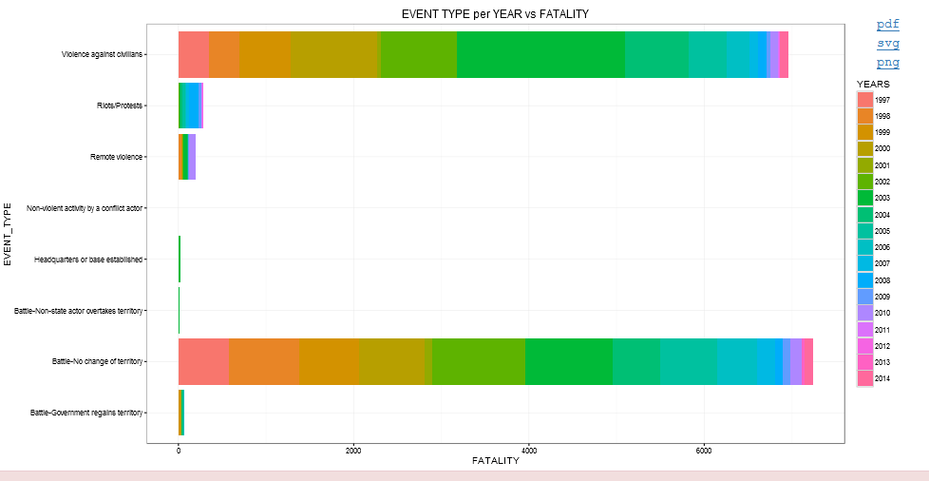

Figure 7: analysis graph of event-type versus fatality over years

## Analysis

Battle no change was the dominant event type that caused a very high rate of fatalities especially in Acholi region followed by Violence against civilians in the same region. According to ACLED, the main actors were Civilians and Military forces against the LRA rebels. Another region that was eye catching was the Karamojong region with the same event types dominating. The reasons for these violences were cattle raid made by the Karamojong militia and disarmament of guns from the same actors. The most none occurring event type that caused the least fatalities was the non-violent activity by a conflict actor and battle non state actor overtakes territory. These fatalities have been reducing with time except in the western region.

## Observation and recommendation

According to this analysis, there are few regions are or where dominating the occurrence of these fatalities that calls for more security in search regions where these violences are still happening. Therefore, measures that are more peaceful should be entertained to reduce on the fatalities.

# Analysis for event type per year against region

## Analysis

Battle no change and violence against civilians were the dominant event types in causing high rates of fatalities over the years. Violence against civilians was most dominant in 2002 and 2003 causing the highest of fatalities followed by battle no change those same two years. The event type that caused the least fatalities over the years was the non-violence activity by a conflict actor.

## Observation and recommendation

For over years the fatality rate has been reducing with some event types such as battle government regains territory and Non-violent activity by a conflict actor going off the charts. However, their some event types that still exist since such as battle no change and violence against civilians though they have somehow reduced but still calls for attention. Riots and protests is also another event type that has been occurring in recent years thus causing some fatalities especially in 2010.

# Analysis for interactions per year vs event type

Under regions their different districts that we need to analyzed

## Analysis for fatalities in a region

### ACHOLI REGION

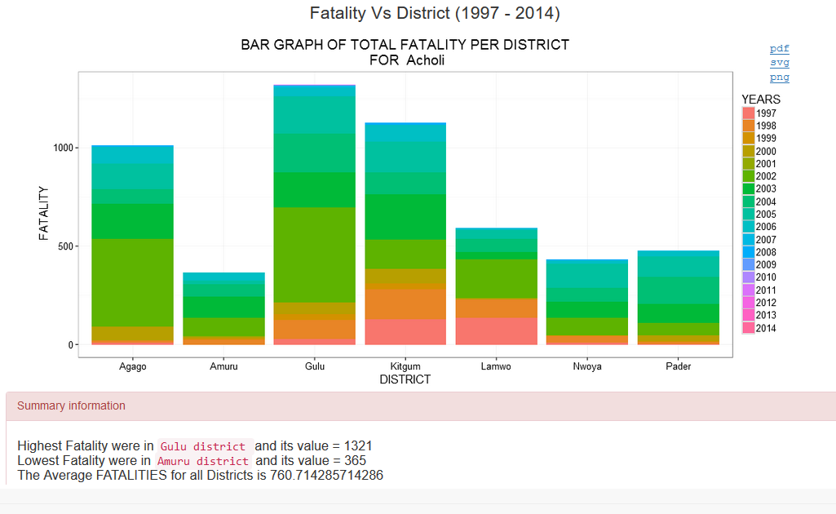

Figure 8: analysis graph of fatality in Acholi region

Gulu had the highest number of fatalities followed by kitgum and Ameru having the least fatalities. These fatalities were commonly notice in the years of 2002, 2003 and 2004. These fatalities have been reducing for over the years.

### ELGON REGION

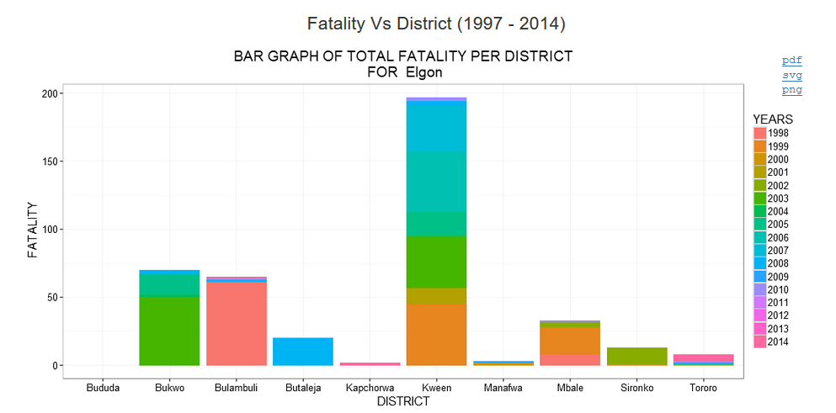

Figure 9: analysis graph of fatality in Elgon region

Kween district had the highest number of fatalities followed by Bukwo district with fatalities mostly happening in 1998(Bulambuli district), 1999(Kween district), 2003(Bukwo), 2007, 2008, 2009(in Kween district). Kapchorwa had the least fatalities and only happening just of recent in 2013 and 2014.

### CENTRAL 1 REGION

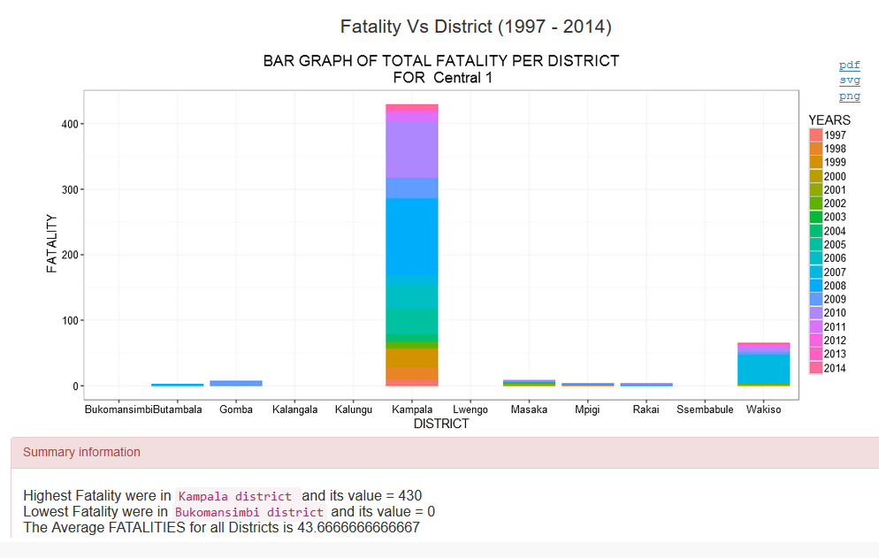

Figure 10: analysis graph of fatality in Central 1 region

Kampala district registered the highest number of fatalities with most of these appearing in 2006, 2007, 2008, 2009 and 2010. Kalangala, Bukomansimbi, Kalungu, Lwengo and Ssembabule registered the list number of fatalities. Kampala district is in high need of maximum security to carter for these violences.

### CENTRAL 2 REGION

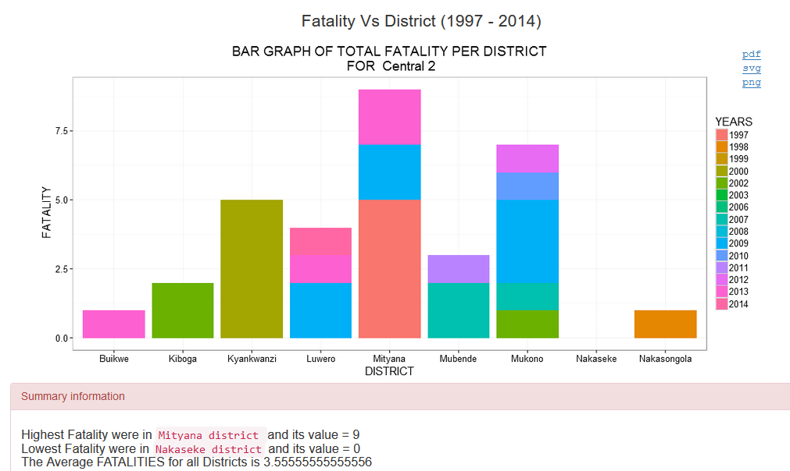

Figure 11: analysis graph of fatality in central 2 region

Mityana District registered the highest number of fatalities with the most of them appearing in 1997, 2009 and 2014. The event types were mostly riots or protests and the actors were civilians against the police force. Nakaseke district appeared as most non-violent District almost registering no fatalities in the whole region.

### EAST CENTRAL REGION

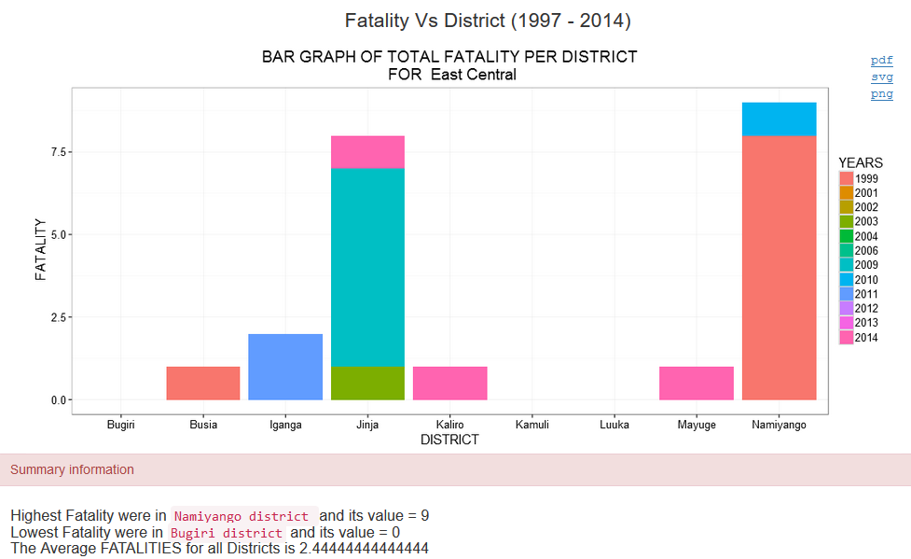

Figure 12: analysis graph of fatality in East Central region

Namiyango registered the highest fatality with most of them having happened in 1999 and 2011 and the least happening in Bugiri, Kamuli and Luuka.

### KARAMOJONG REGION

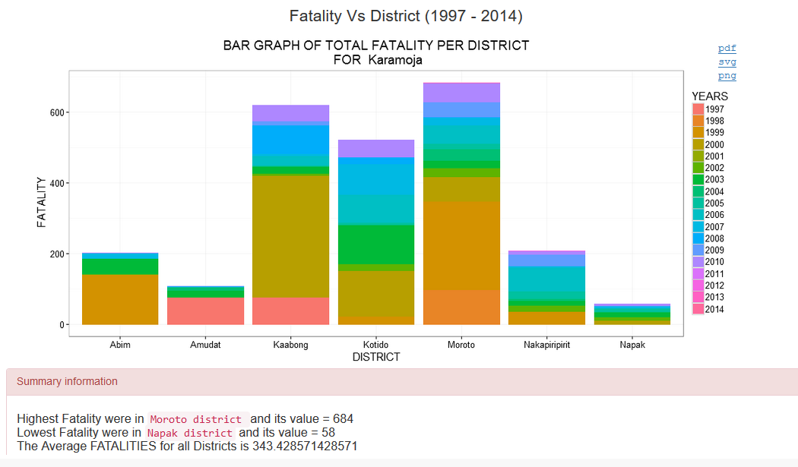

Figure 13: analysis graph of fatality in Karamoja region

Moroto District had the highest number of fatality followed by kaabong with most of them happening in 1999, 2000. The least fatalities were registered in Napak.

### SOUTH-WESTERN REGION

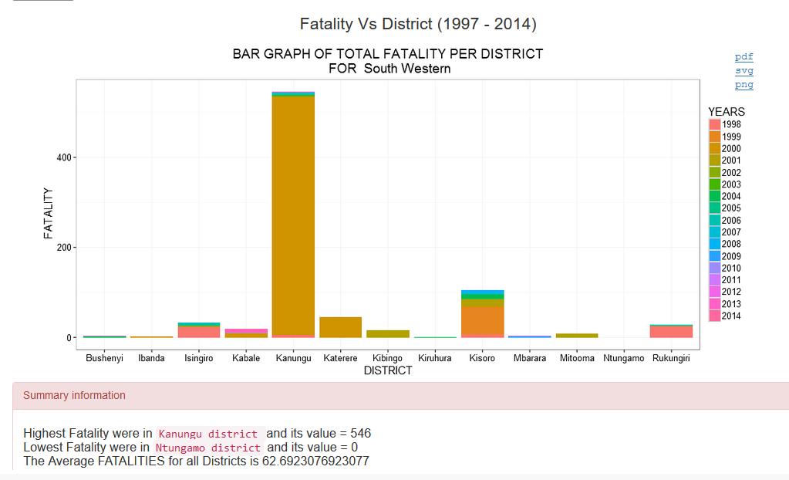

Figure 14: analysis graph of fatality in south western region

Kanungu district registered the highest fatalities with the most of them happening in 2000 Ntugamo that had the least fatalities.